EXPERIMENT 8: ADABOOST CLASSIFICATION

AIM:
To implement the AdaBoost boosting technique for classifying students' results and analyze the model's performance.

ALGORITHM:
- Import Pandas, Matplotlib, and the required Scikit-learn modules.
- Load the dataset from data.csv.
- Select Hours_Studied, Attendance, and Assignments as input features.
- Select Result as the target variable.
- Split the dataset into training and testing sets in an 80:20 ratio.
- Create an AdaBoost classifier with 50 estimators.
- Train the model using the training data.
- Predict the results for the testing data.
- Calculate accuracy, the confusion matrix, precision, recall, and F1-score.
- Extract and plot the feature importance values.
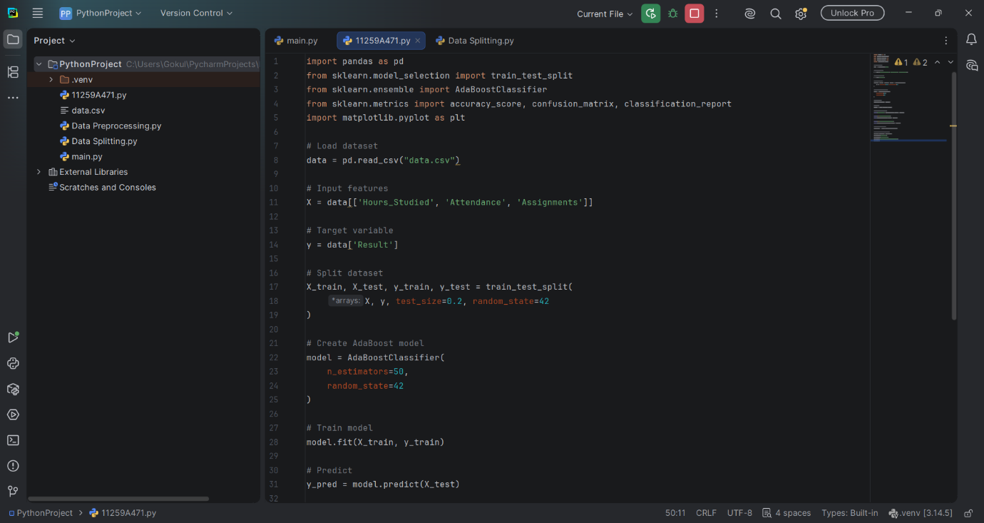

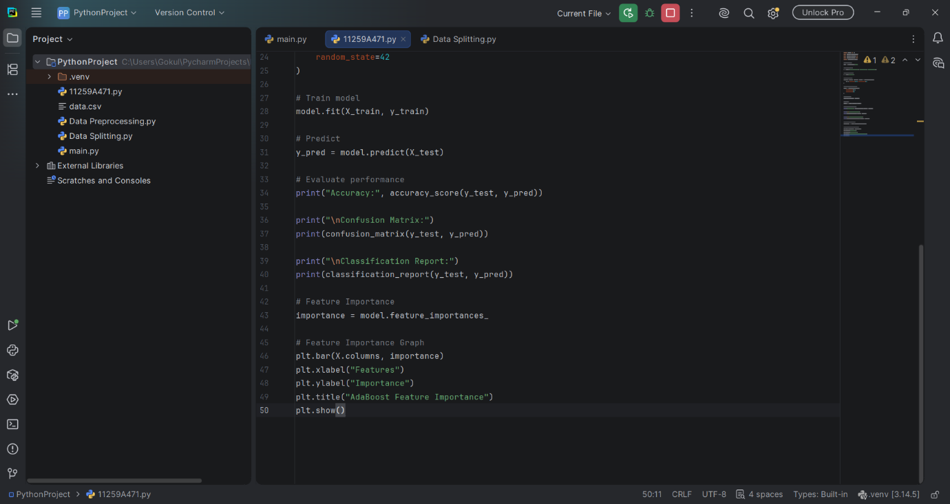

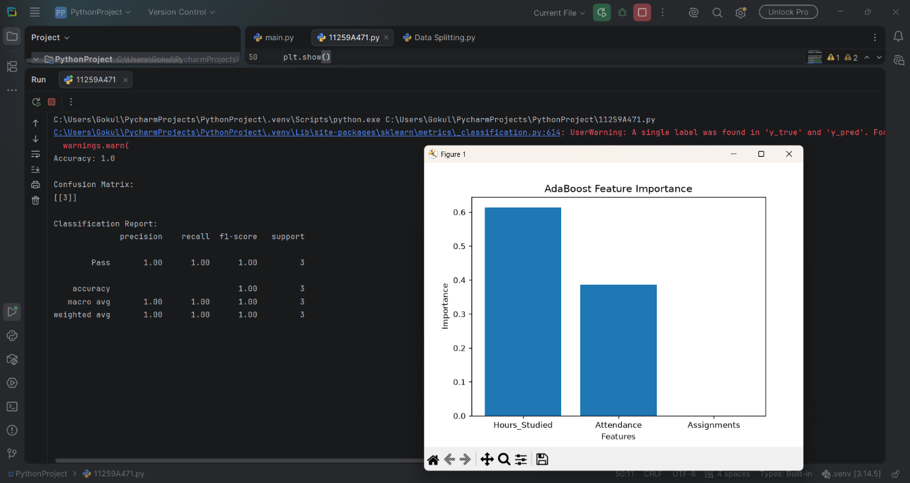

RESULT:
The AdaBoost classification model was successfully implemented to predict students' results. Its performance was evaluated using classification metrics, and a feature importance graph was generated.

